DATA VISUALIZATION USING POWER BI
SALES DATASET
Dataset link :
https://www.kaggle.com/datasets/atharvasoundankar/sales-dataset-2000
load dataset:
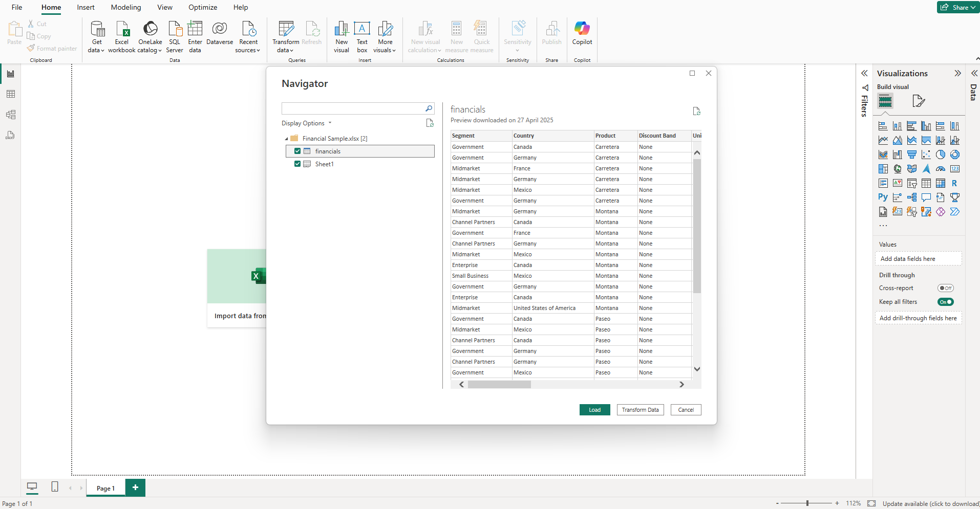
Data transformation using Power Query editor:
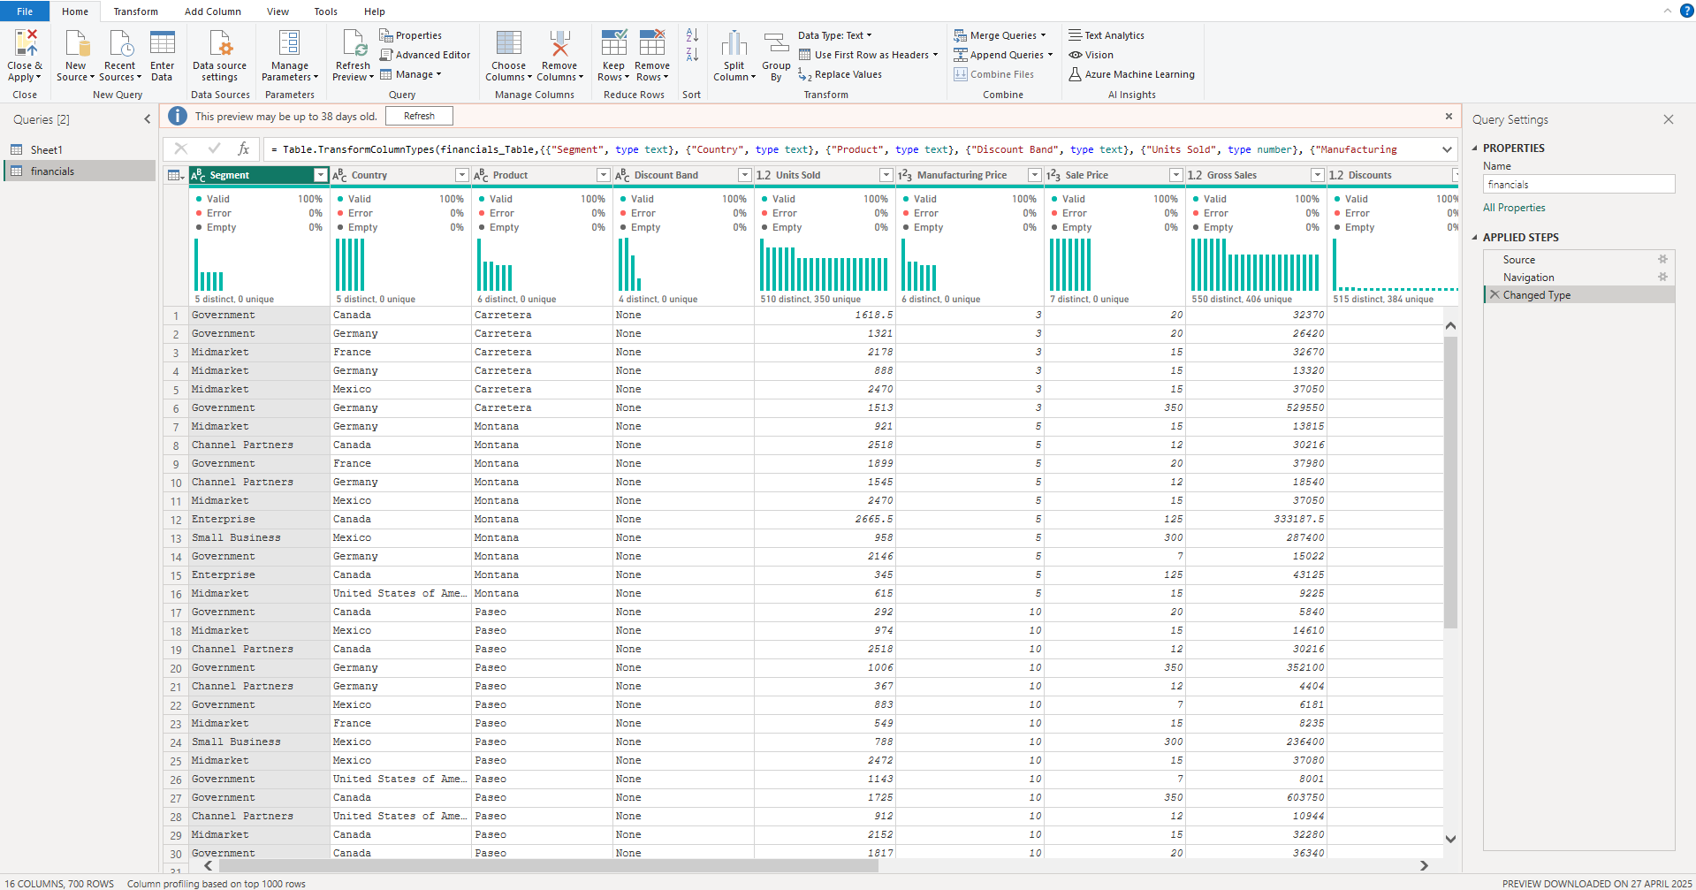
Data Analysis and Visualization :
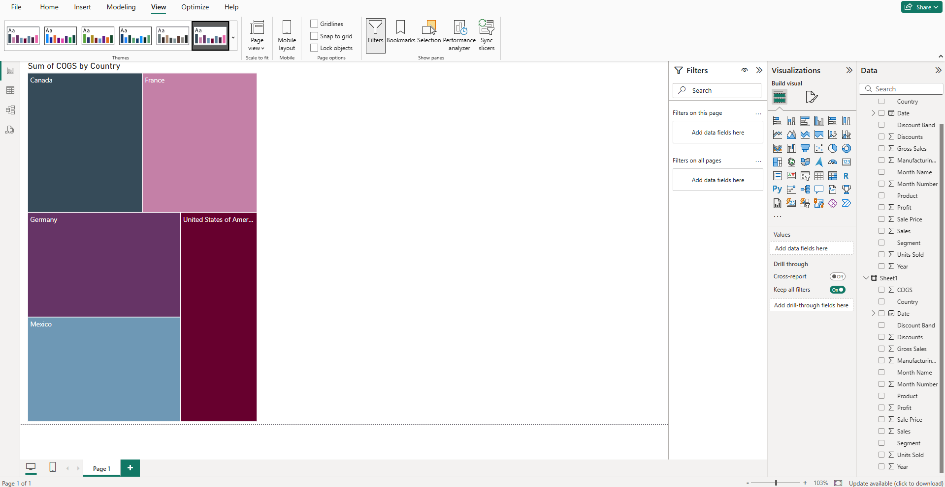
Optimization :
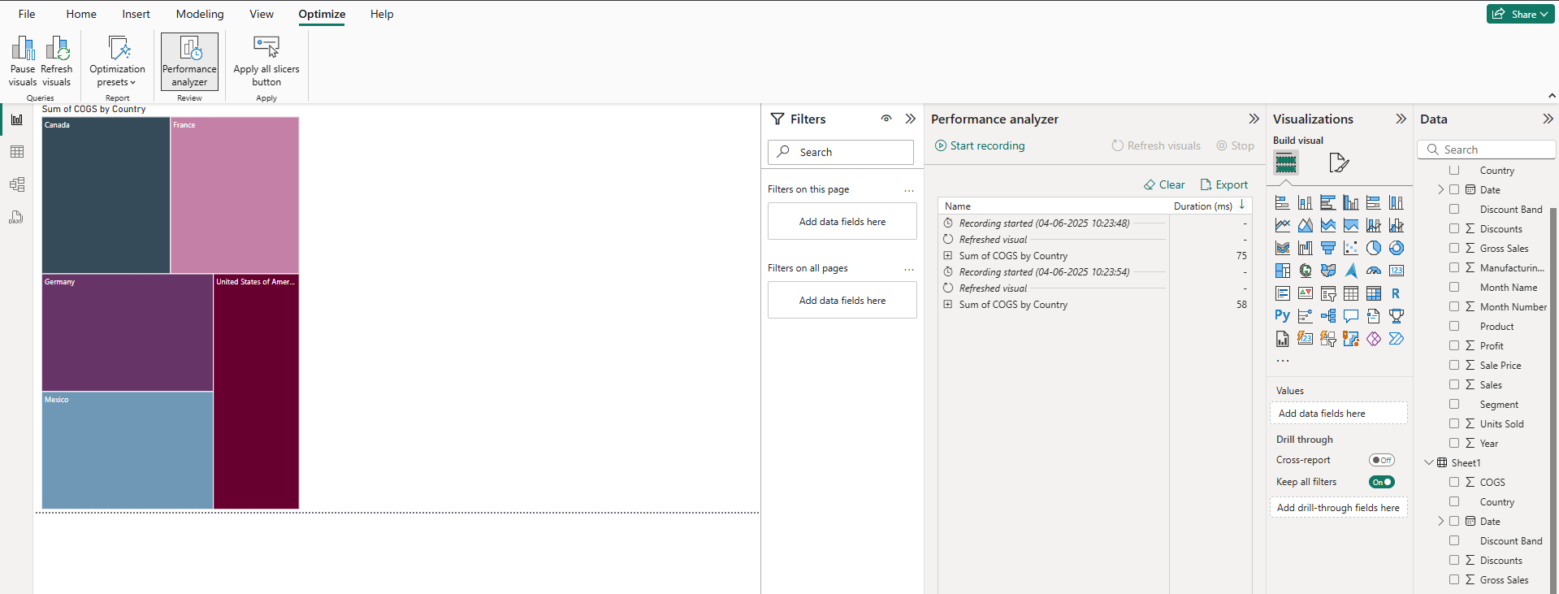

Finding outliers using advanced analysis:
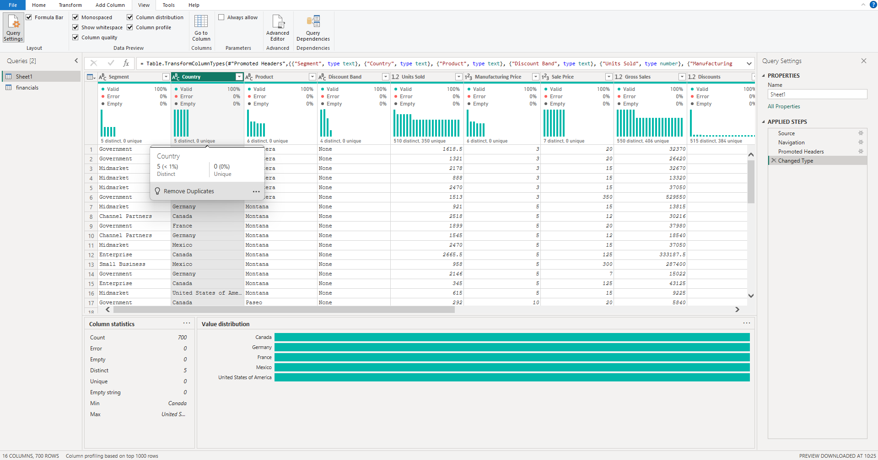

Dashboard:
